**Md. Fazlul Karim**

**ID – 2014182643**

**Sec - 01**

**Ans no – 1**

**Single:** single(X) converts the vector X to single precision. X can be any numeric object (such as a DOUBLE).

**Double:** double(X) returns the double precision value for X. If X is already a double precision array, double has no effect.

**Format:** format Set output format. format with no inputs sets the output format to the default appropriate for the class of the variable. For float variables, the default is format SHORT.

**Format long:**  Scaled fixed point format with 15 digits for double and 7 digits for single.

**str2num:** str2num Convert character array or string scalar to numeric array. X = str2num(S) converts a character array or string scalar representation of a matrix of numbers to a numeric matrix.

**Num2str:** num2str Convert numbers to character representation.

**Int2str:** int2str Represent integers as character array. S = int2str(X) rounds the elements of numeric matrix X to integers and converts the result into a character array that represents the numbers.

**mat2str** Represent matrix as character vector in MATLAB syntax. STR = mat2str (MAT) represents the matrix MAT as a character vector so that EVAL(STR) produces the original matrix (to within 15 digits of precision). Conversions of non-scalar matrices contain brackets [].

**Reshape:** reshape Reshape array. reshape (X, M, N) or reshape (X, [M, N]) returns the M-by-N matrix whose elements are taken column wise from X. An error results if X does not have M*N elements.

**sort:** Sort in ascending or descending order. B = sort(A) sorts in ascending order.

**Ans No – 2**

1. round(X) rounds each element of X to the nearest integer. The floor function rounds values to the nearest integer toward negative infinity.
2. The mod function produces a result that is either zero or has the same sign as the divisor. The rem function produces a result that is either zero or has the same sign as the dividend. Another difference is the convention when the divisor is zero.
3. Mean: It will return the mean of the elements of A along the first array.

Median: It will return the median value.

**Ans No – 3**

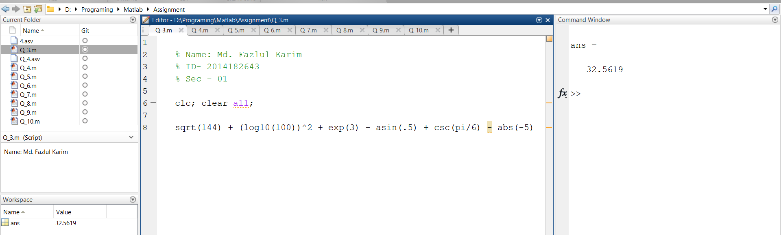

**Ans No – 4**

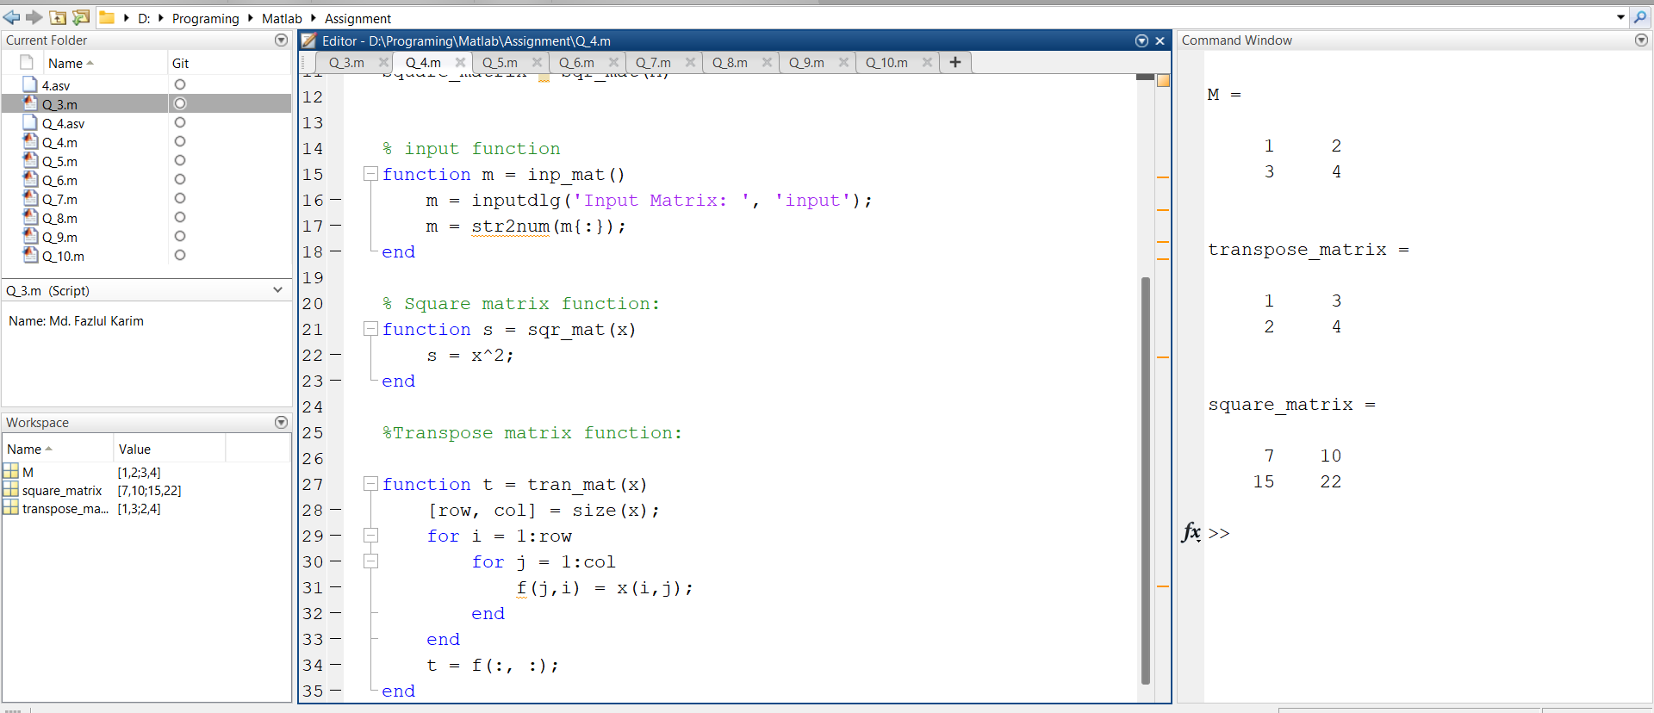

(a)

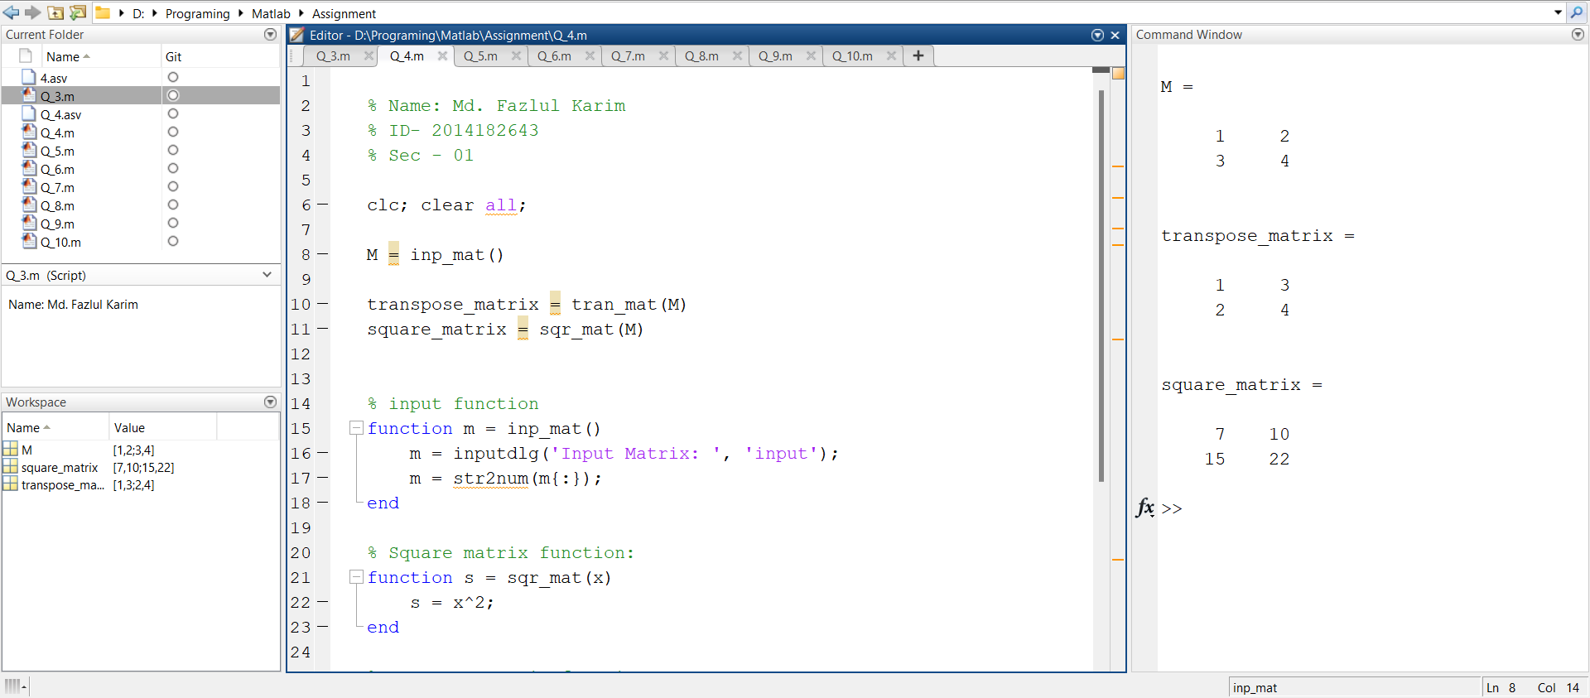

(b)

**Ans No – 5**

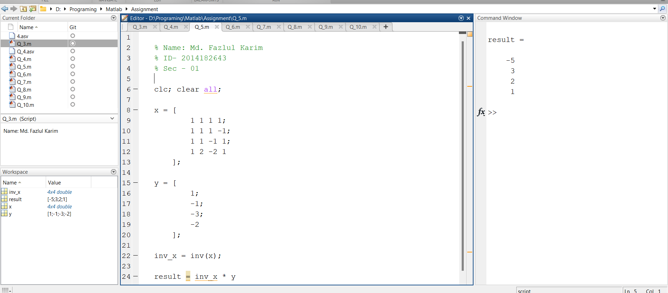

**Ans No – 6**

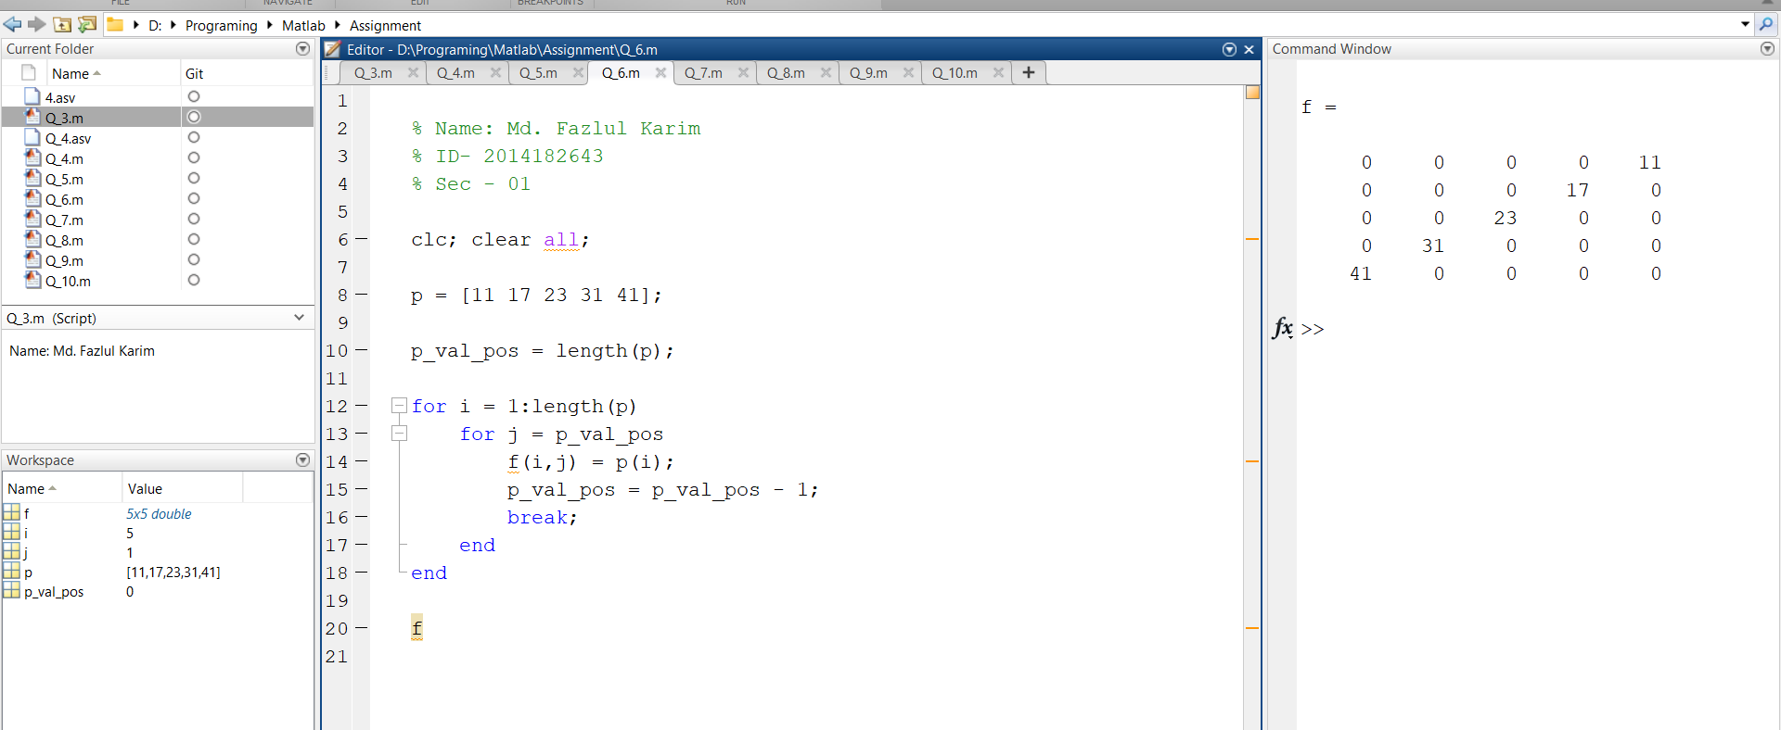

**Ans No – 7**

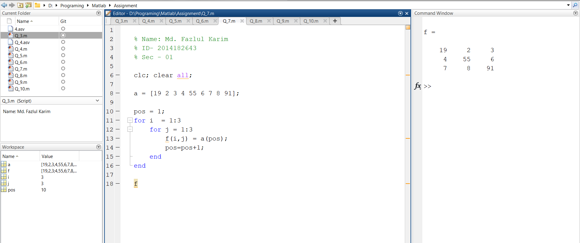

**Ans No – 8**

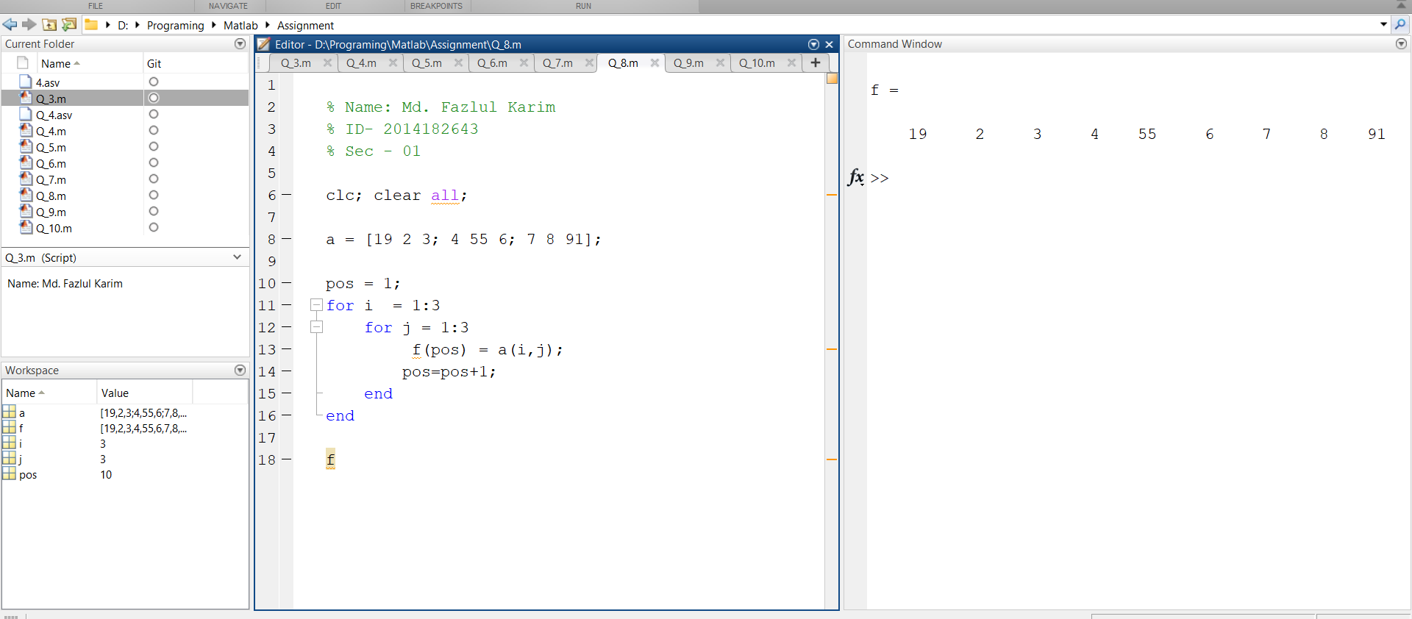

**Ans No – 9**

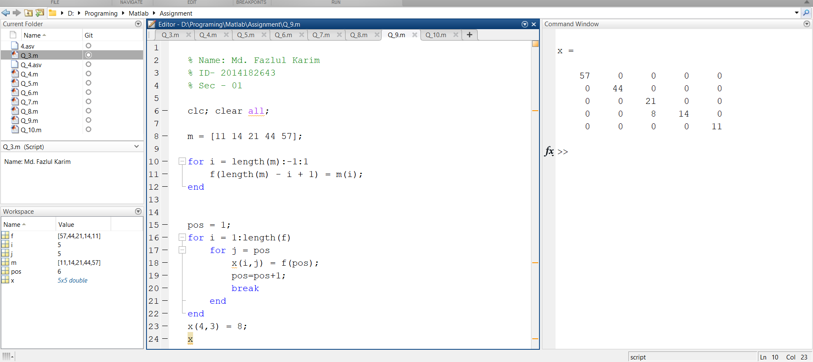

**Ans No – 10**

